PASCAL IMITATION JEWELLERY

**Group Members**

|  |  |  |
| --- | --- | --- |
| *S.no* | *Student ID* | *Student Name* |
| 1 | Student1288017 | Rana Haris Iqbal |
| 2 | Student 1288373 | Rana Baber Iqbal |

**Project Advisor**

### **Sir Subhan**



**Aptech Computer Education**

Korangi Center

**ACKNOWLEDGEMENT**

First of all we would like to thank ALLAH the almighty who make us able to complete this project.

After that we would like to express profound gratitude to our internal project advisor, Center Senior Faculty, **SIR SUBHAN** for her precious support, back-up, supervision and useful suggestions throughout this project. Her moral support and continuous help enabled us to complete our work successfully. We are also highly thankful to the ***Center Management*** for their valuable suggestions, healthy analysis and support throughout this project.

We are grateful to the faculty members of Aptech Korangi Center who were always there to help us despite of their personal workload.

We are as ever, especially indebted to our parents for their love and support throughout our life. We also wish to thank our classmates, friends and all the individuals or groups that were involved in this project by any mean.

**Rana Baber Iqbal & Rana Haris Iqbal**

# **E-Project** **Synopsis**

## Introduction

“PASCAL IMITATION JEWELLERY” is one of the leading manufacturers and suppliers

of Precious, Semi precious and Artificial Jewelry. They sell them under different

brand names. The Quality of the products are renowned for striking features such as

smooth polish, stunning design and excelling clarity, look and feature, luster. The

shop owner wishes to have the website of the jeweler shop where in they want to

describe all the type, brands of the product.

## Technology Used

In order to meet the requirement of our project we have used following underlying technologies.

* HTML5
* CSS3
* Bootstrap 4
* Java script
* JQuery

*Figure 1: Technology Used in Project*

## Website Features

* We have used bootstrap framework so as to make our website responsive. Although it is not as responsive as professional websites are, but we have tried basic implementation of a responsive website.
* . User Friendly Website.
* Color combination is according to Logo.
* Detailed Photography.

.

## Site Requirement

Since we have used bootstrap framework, it might have certain compatibility issues. We used the latest version of the framework and yet it has certain limitation. Below-mentioned is the compatibility chart for bootstrap. We highly recommend this website to be opened on “Google Chrome” due the best compatibility available. [5]

|  |  |  |  |  |  |
| --- | --- | --- | --- | --- | --- |
|  | ***Chrome*** | ***Firefox*** | ***Internet Explorer*** | ***Opera*** | ***Safari*** |
| Android | * Supported | * Supported | * Supported | * Supported | * Supported |
| iOS | * Supported | * Supported | * Supported | * Supported | * Supported |
| Mac OS X | * Supported | * Supported | * Supported | * Supported | * Supported |
| Windows | * Supported | * Supported | * Supported | * Supported | * Supported |

## Website structure

### 

### Bootstrap Grid System

Since we have used bootstrap framework for website. Grid layout [6] making technique have been used in our website. For review, I have mentioned the basic structure of grid system which we have used in our project.

|  |  |  |  |  |  |
| --- | --- | --- | --- | --- | --- |
|  | **Extra Small**  **<576px** | **Small**  **>576px** | **Medium**  **>768px** | **Large**  **>992px** | **Extra large**  **>1200px** |
| **Max container width** | None (auto) | 540px | 720px | 960px | 1140px |
| **Class prefix** | .Col- | .col-sm- | .col-md- | .col-lg- | .col-xl- |
| **# of columns** | 12 | | | | |
| **Gutter Width** | 30px (15px on each side of a column) | | | | |
| **Nestable** | Yes | | | | |
| **Column ordering** | Yes | | | | |

*Table 1: Bootstrap Grid Information*

# Screenshot

Landing Page Or Home Page

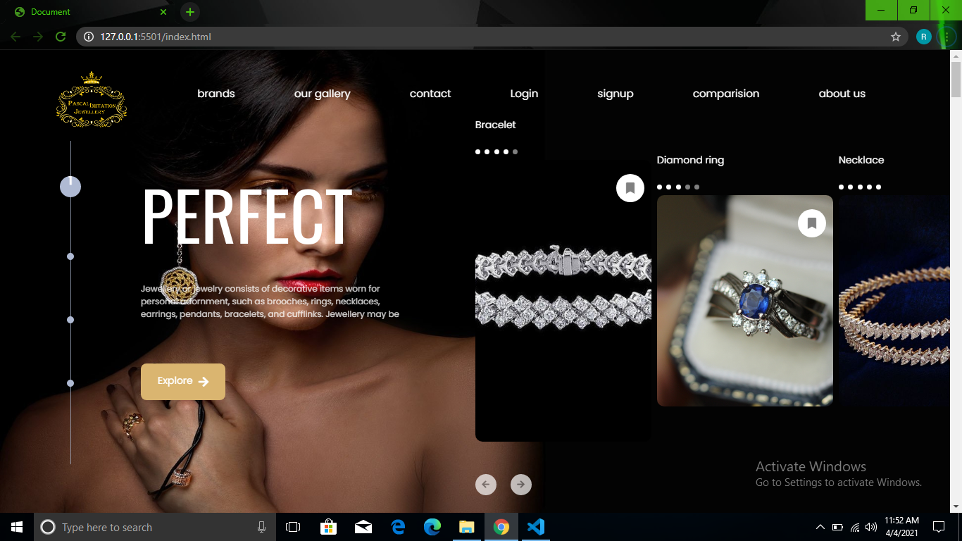

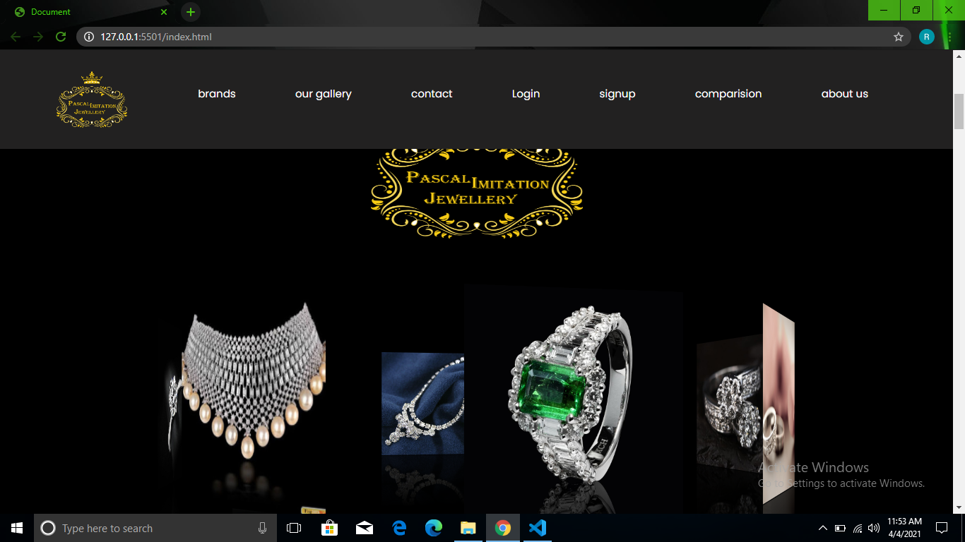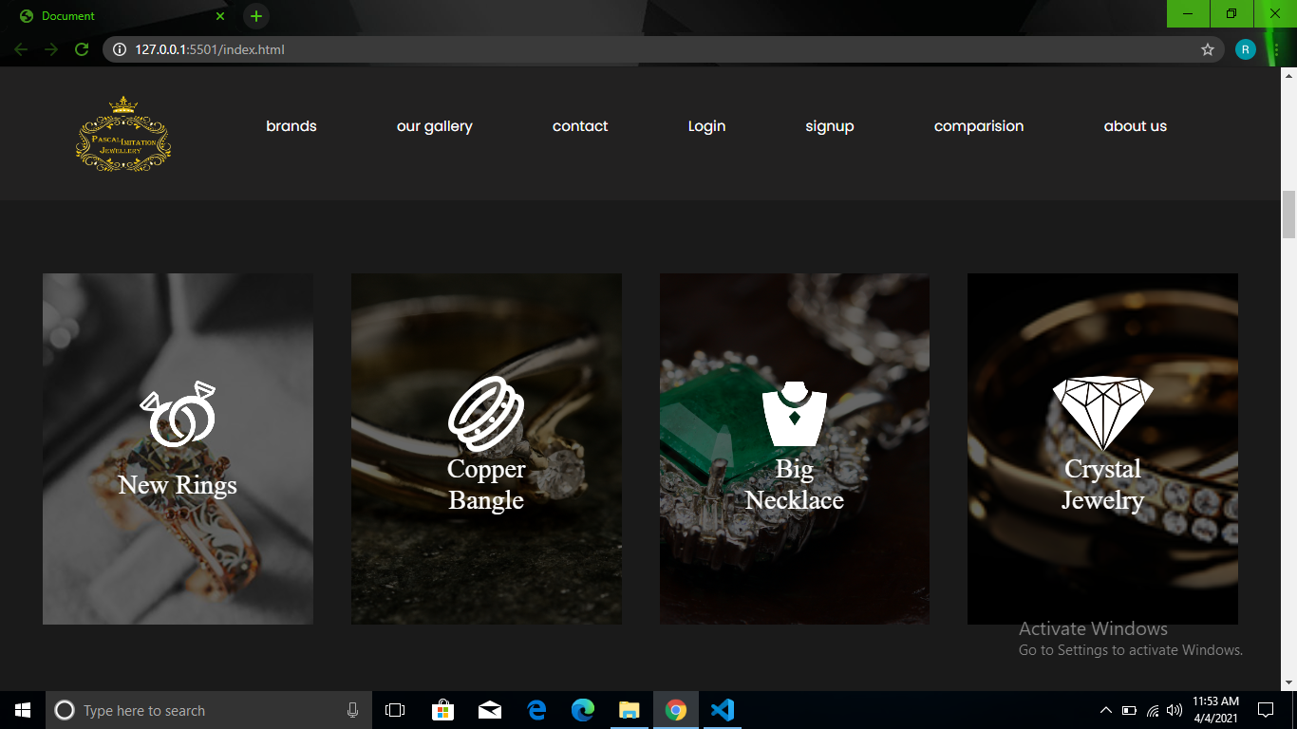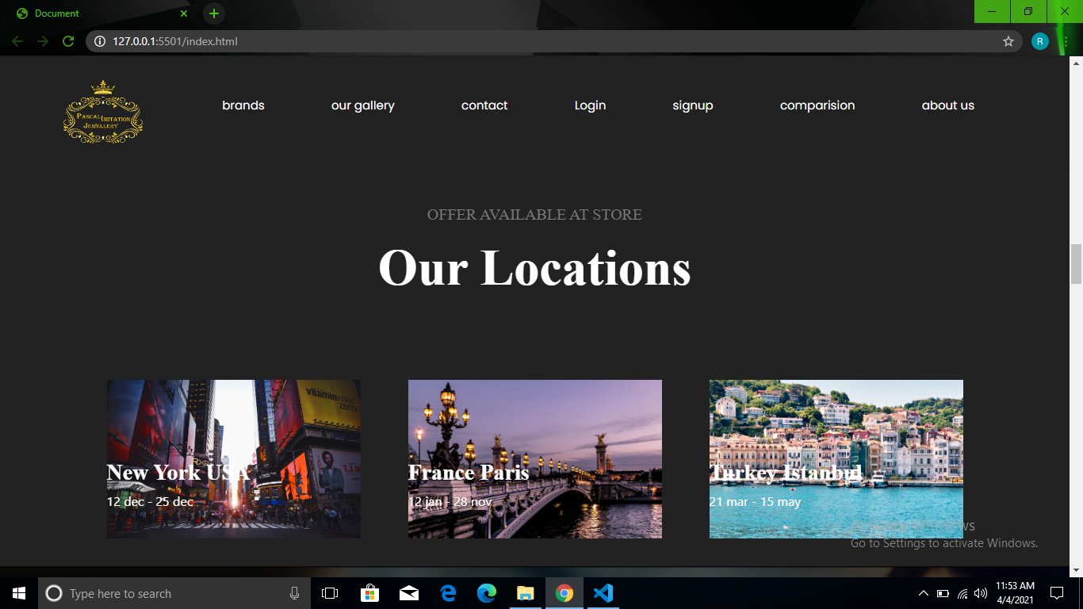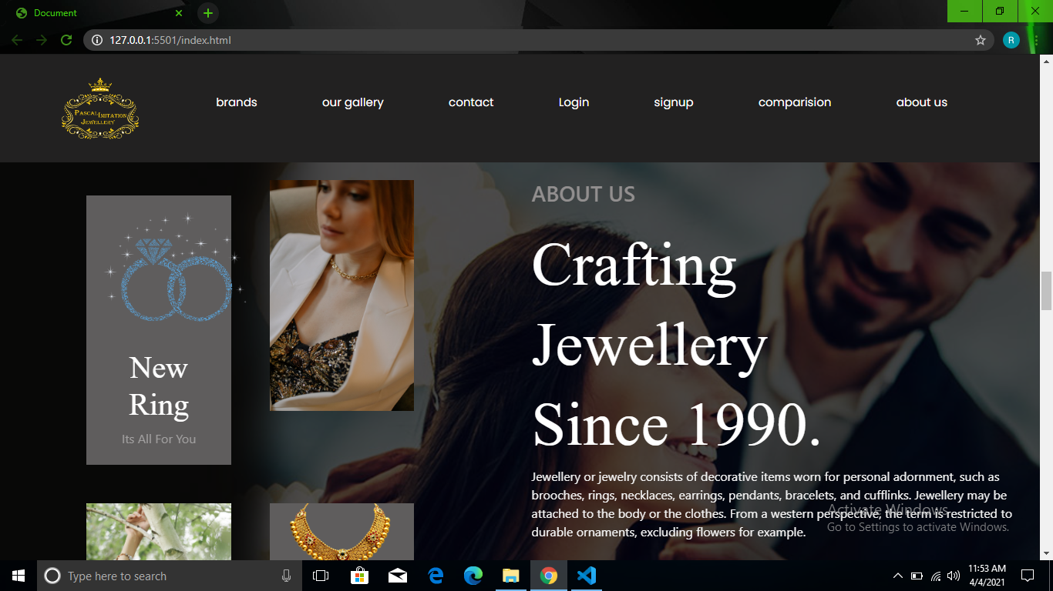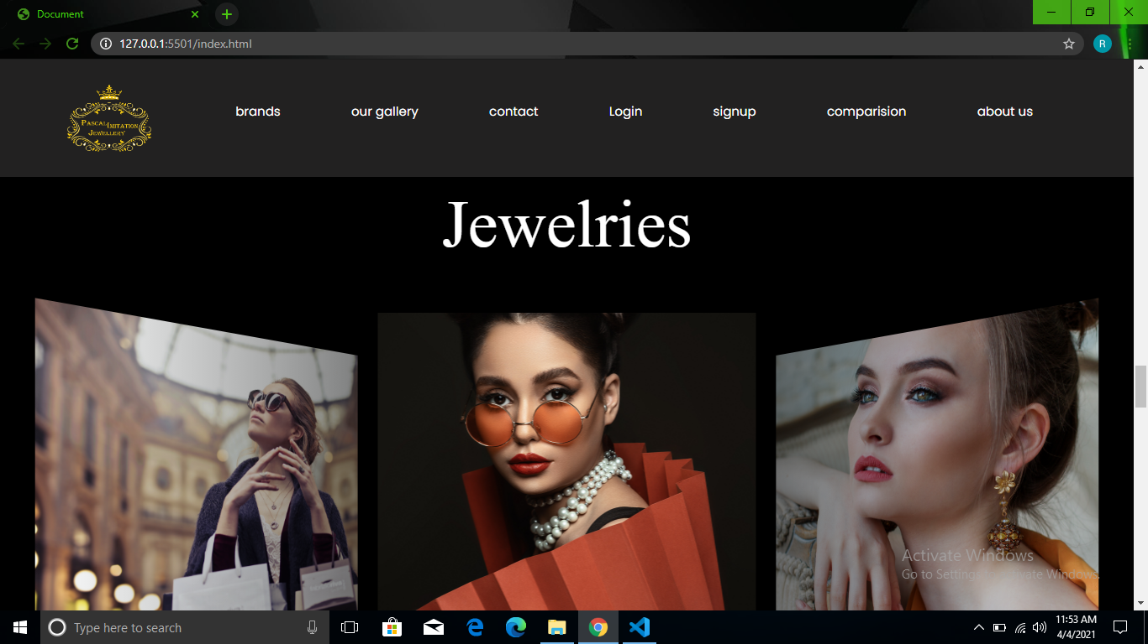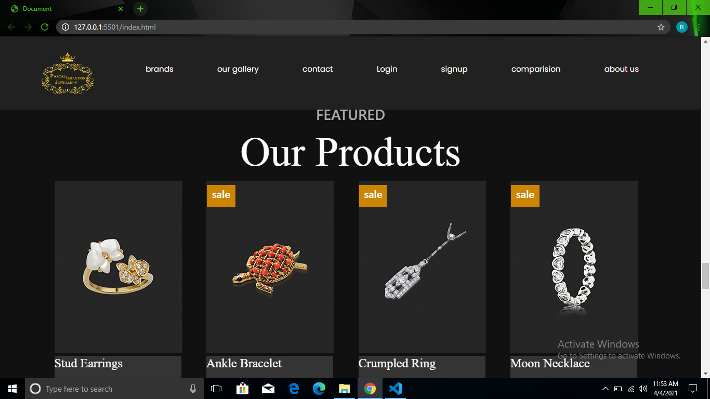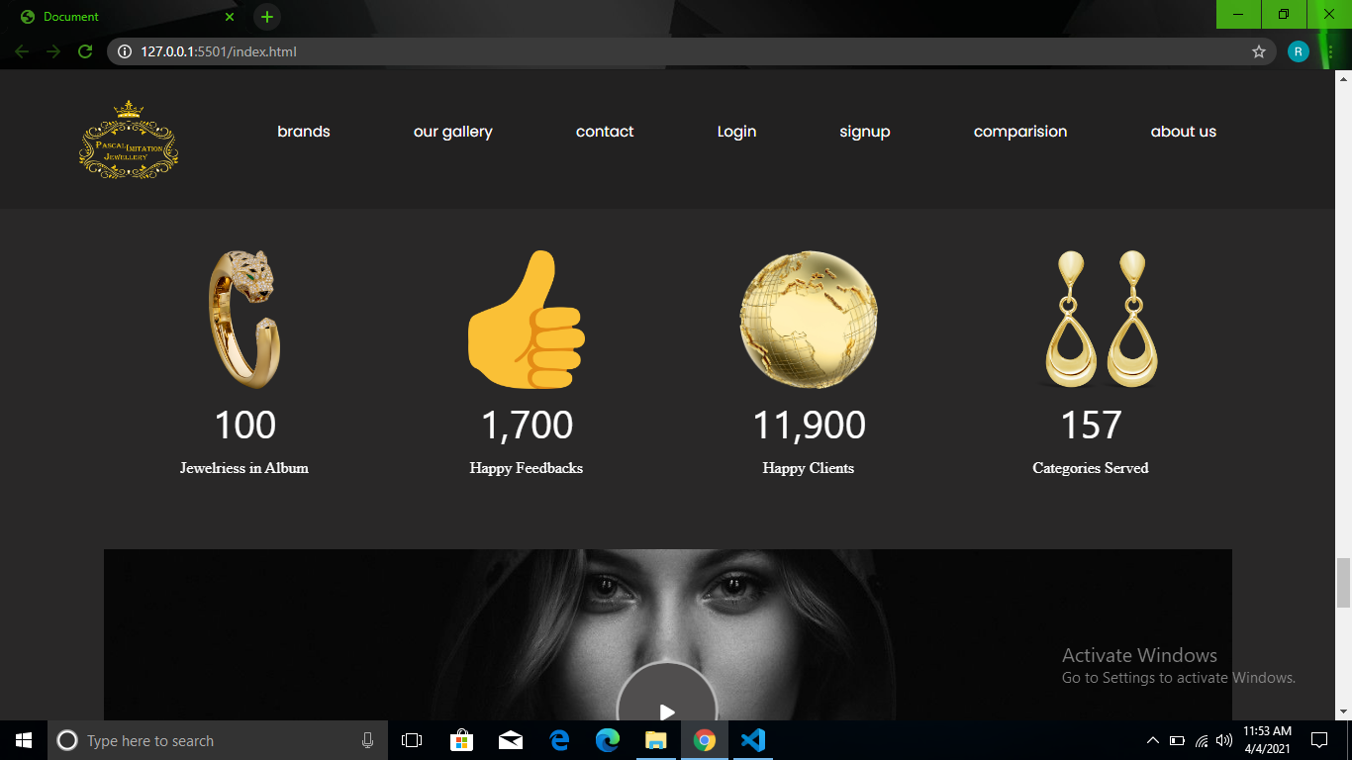

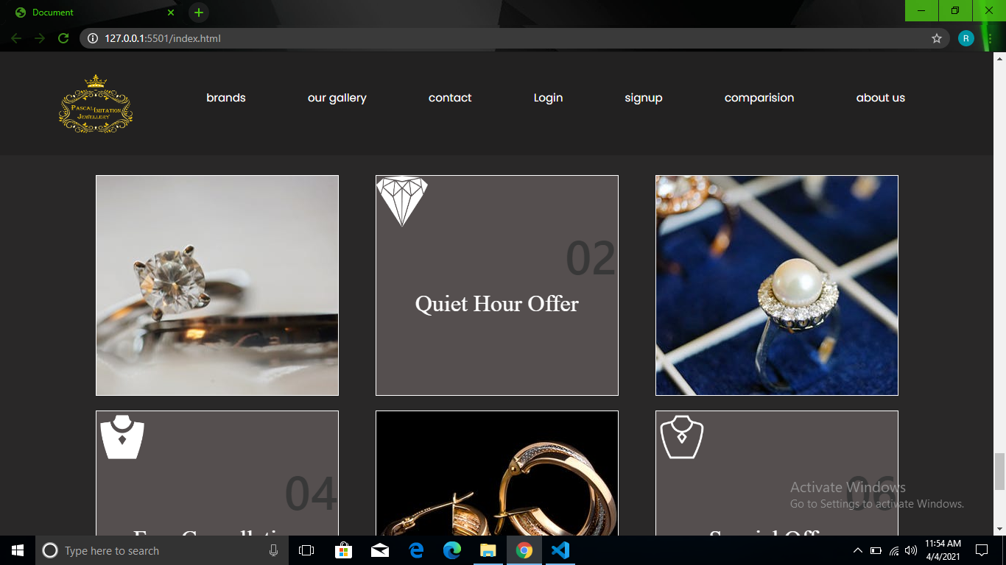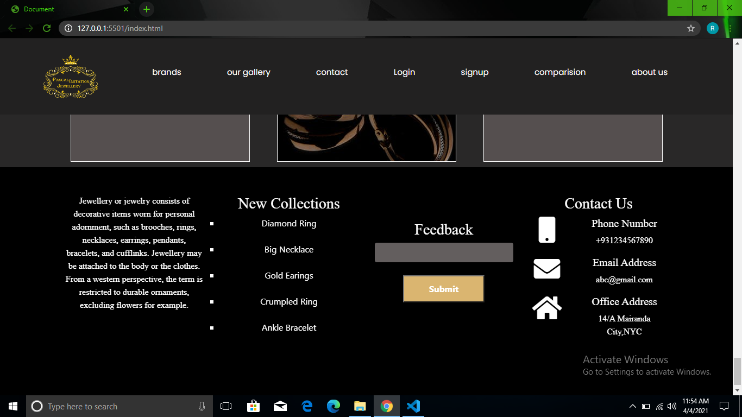

Landing Page Or Home Page

Links

Source Code

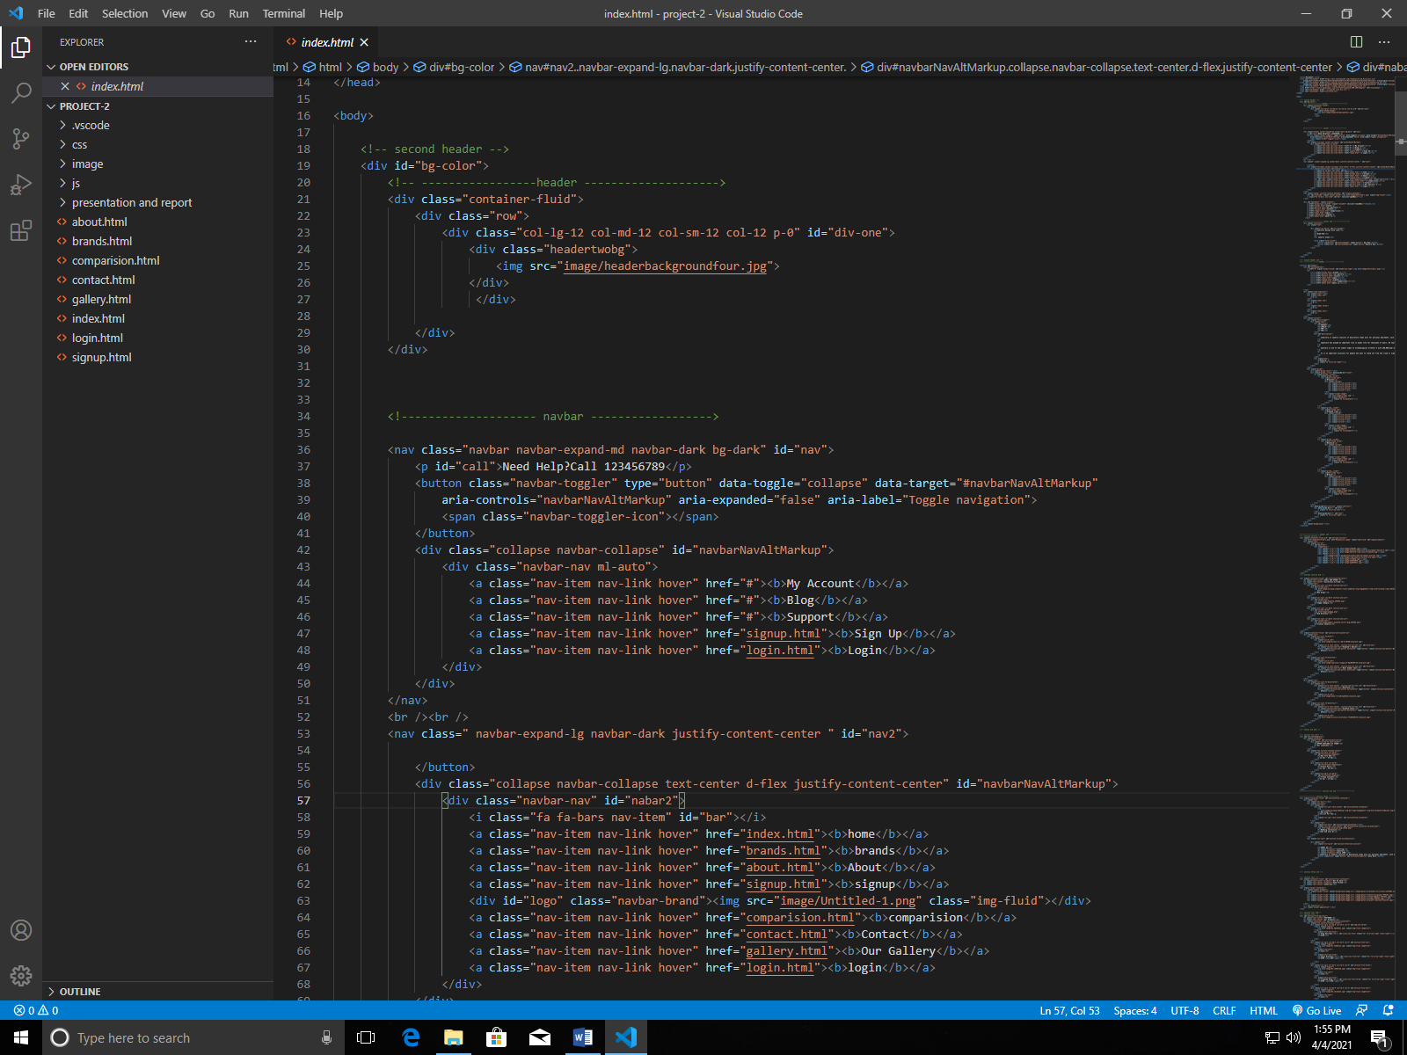

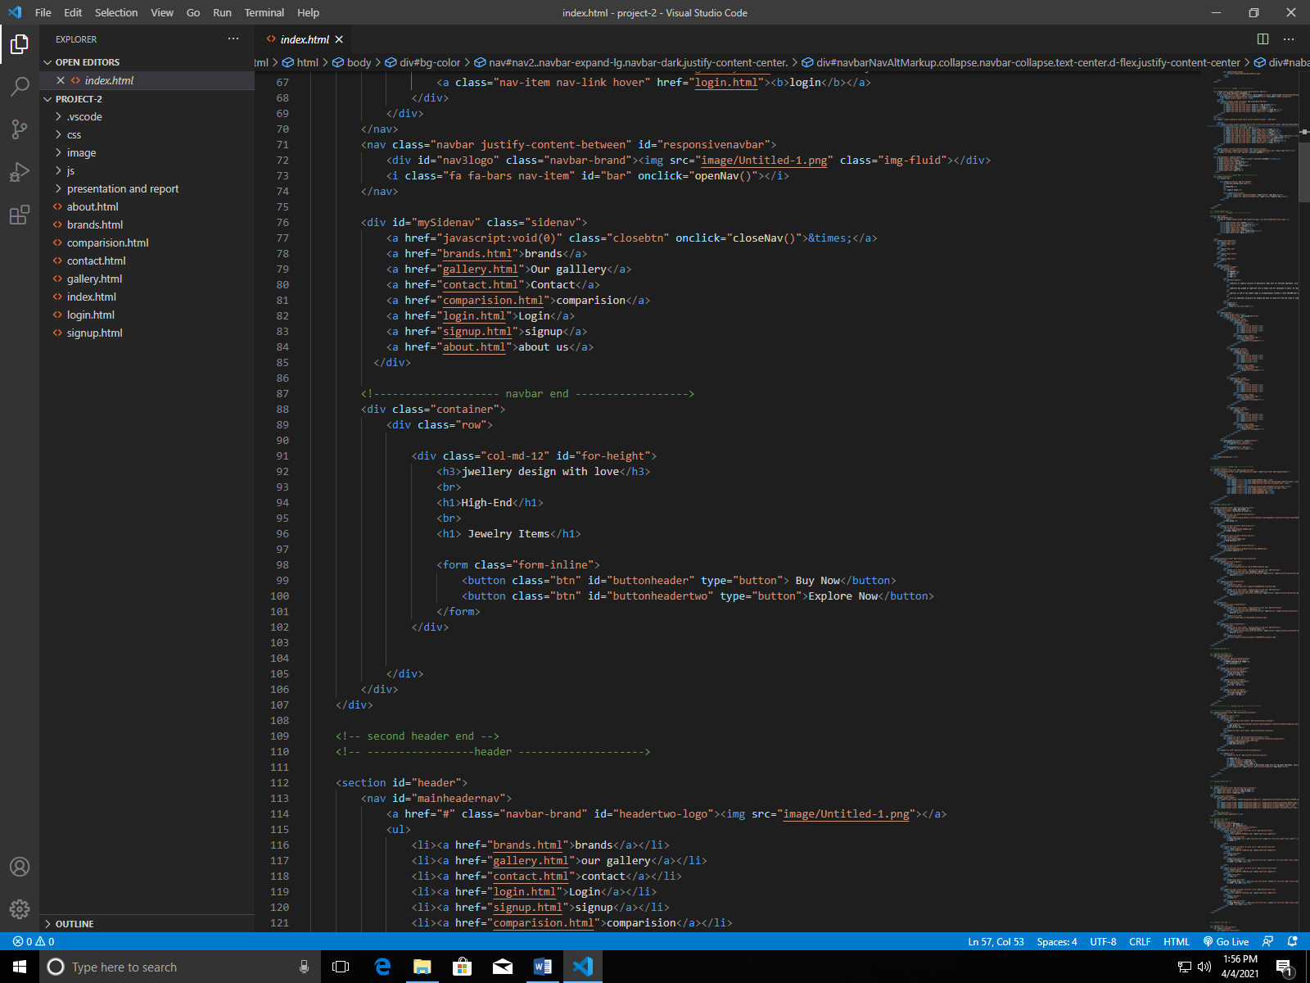

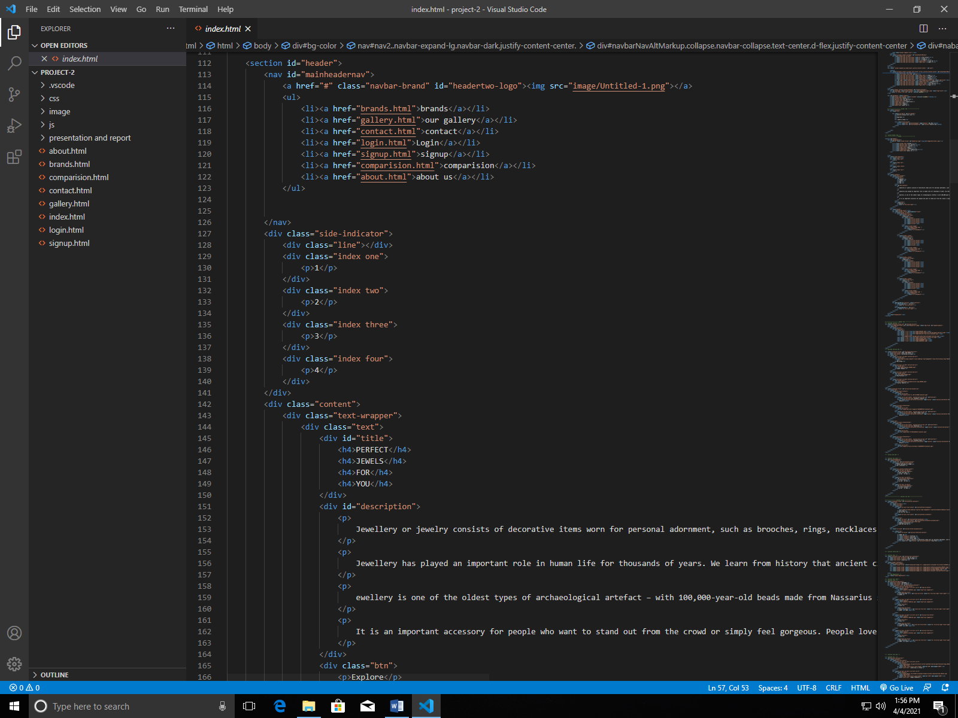

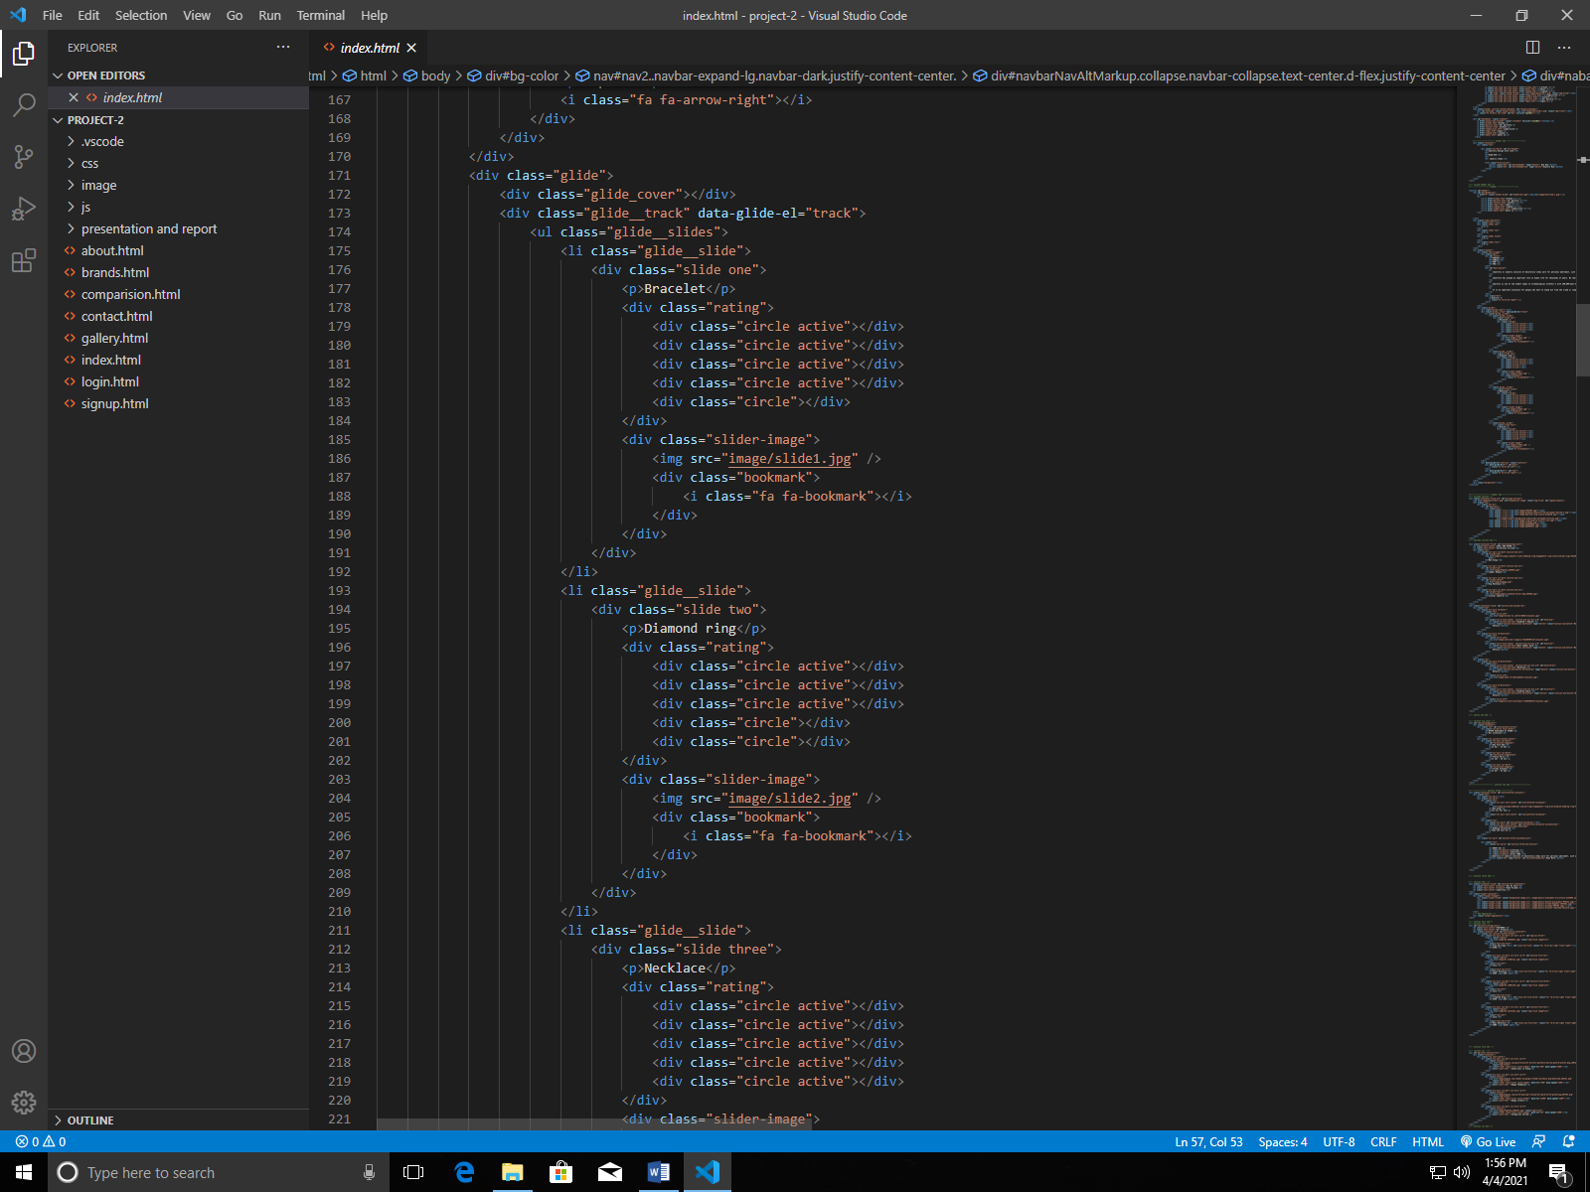

Image gallery

Screenshots

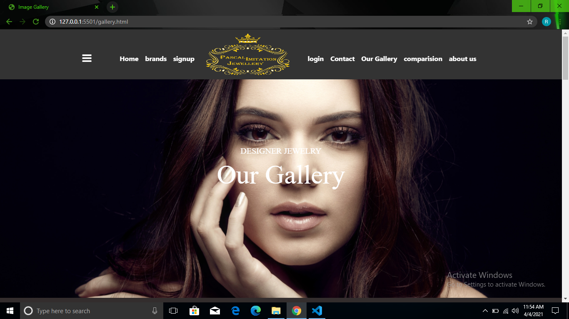

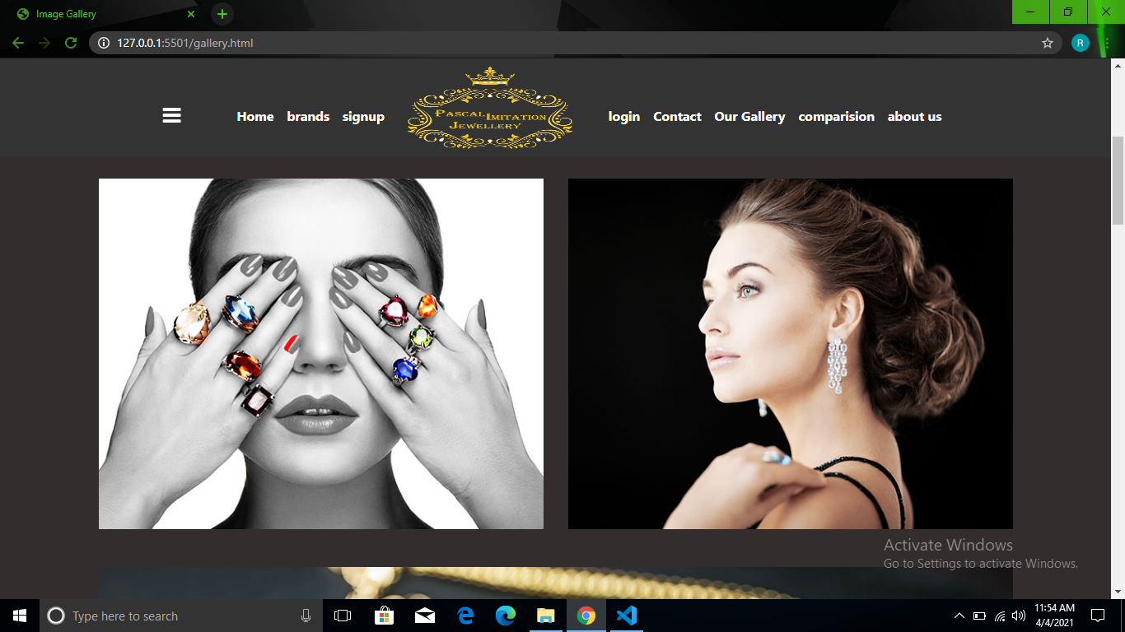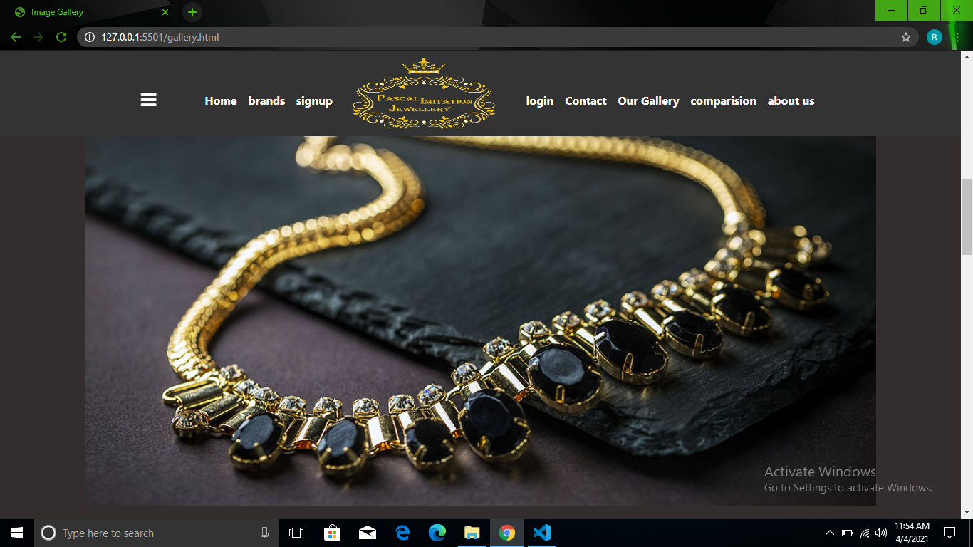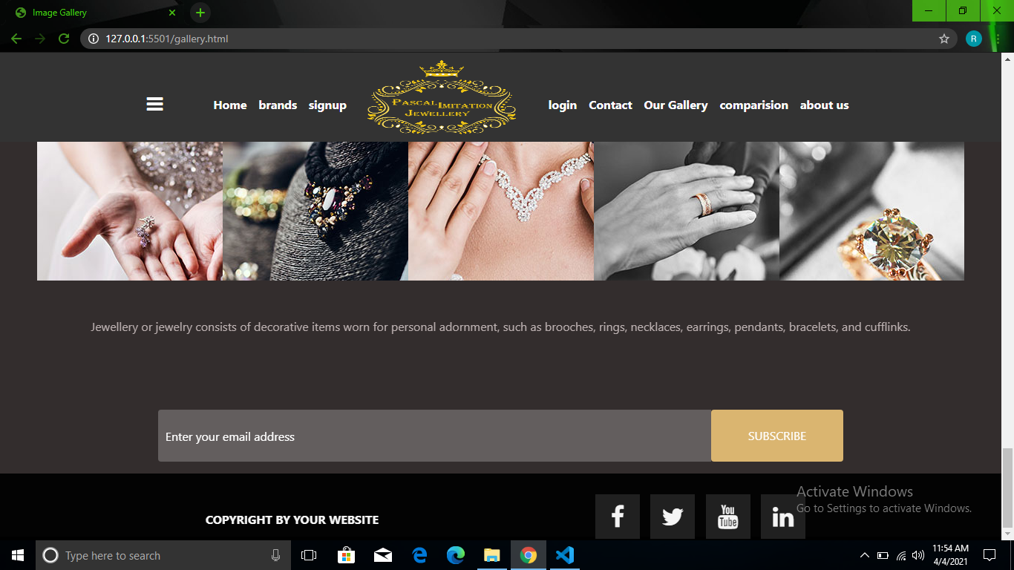

Source Code Of Pages

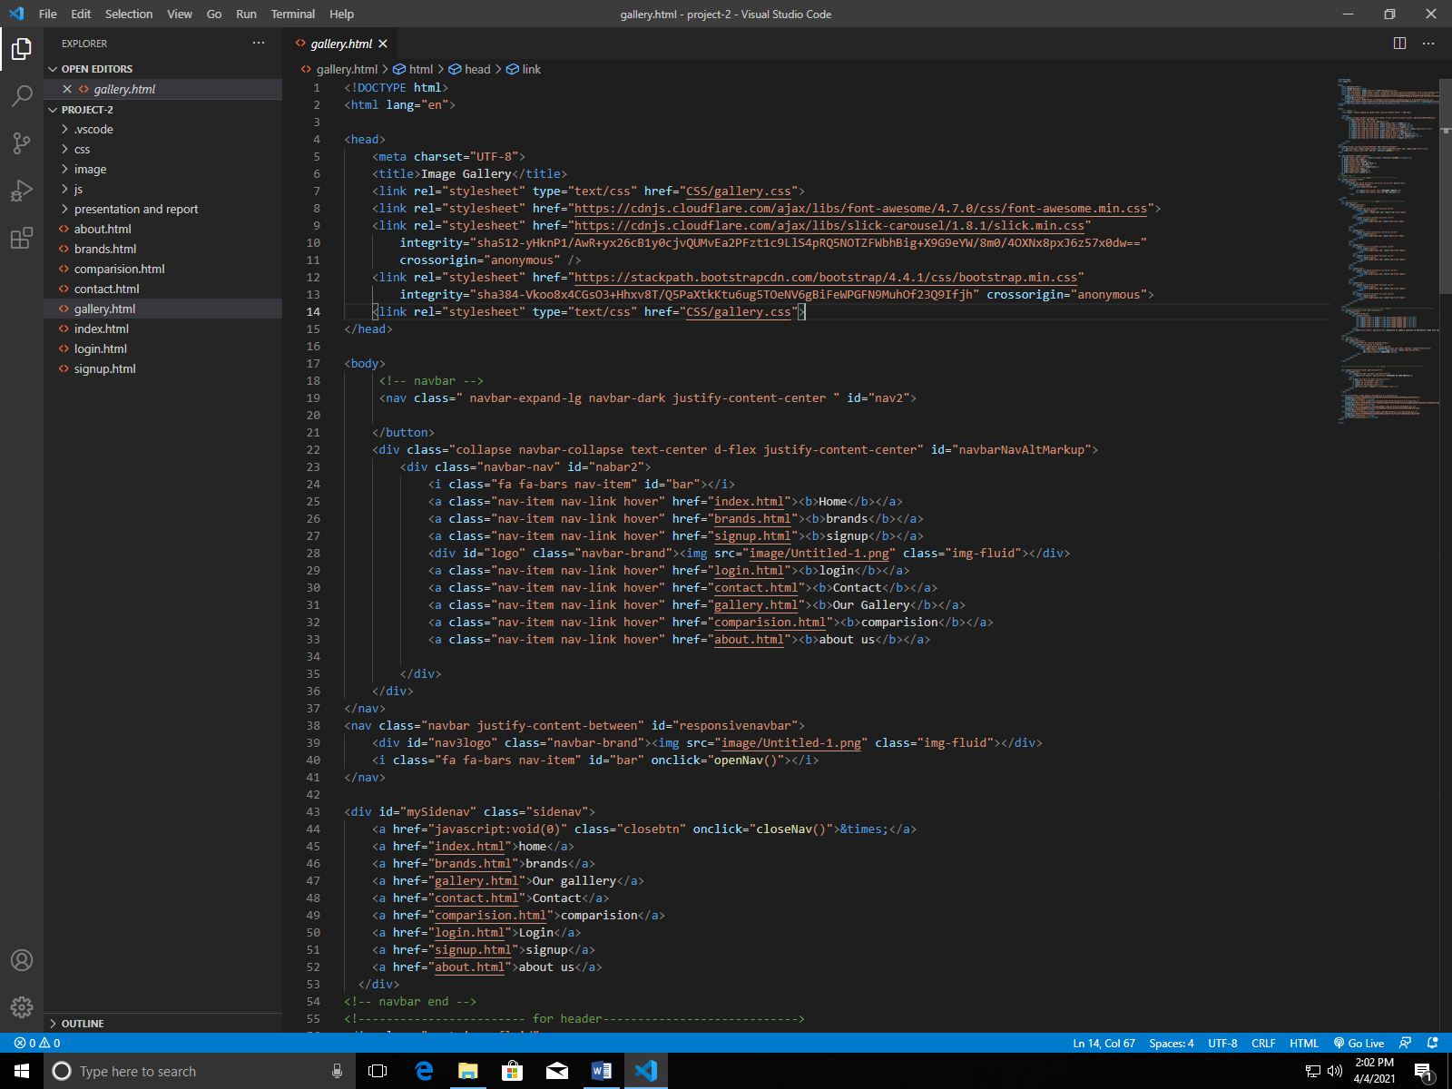

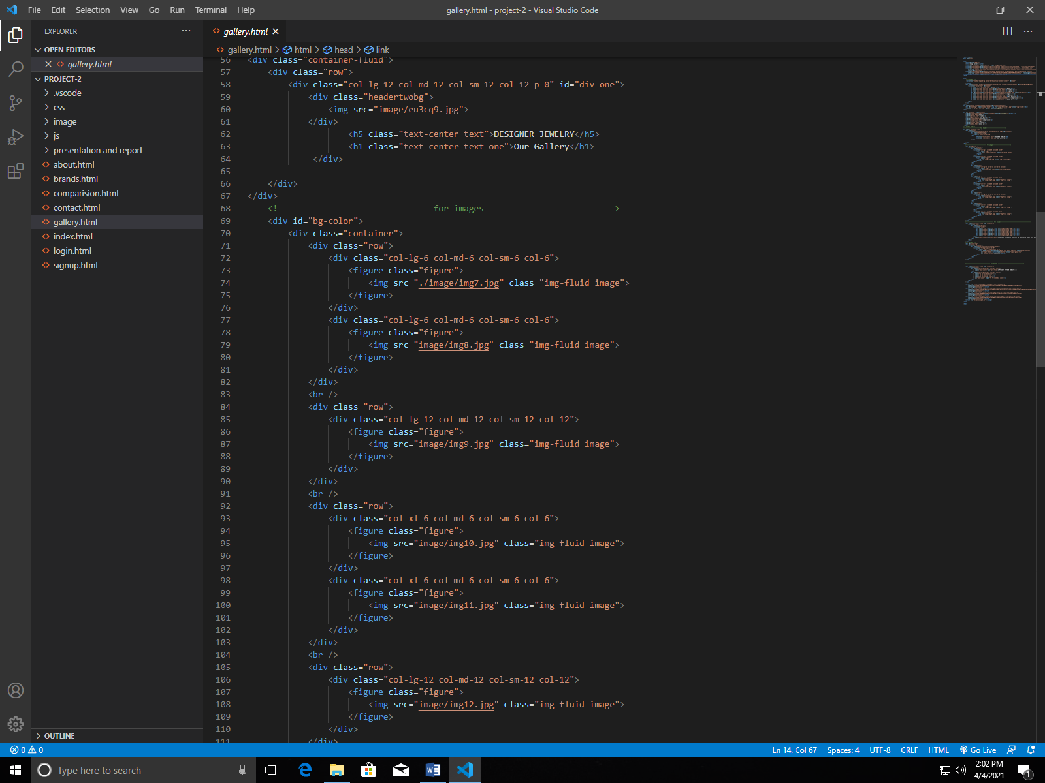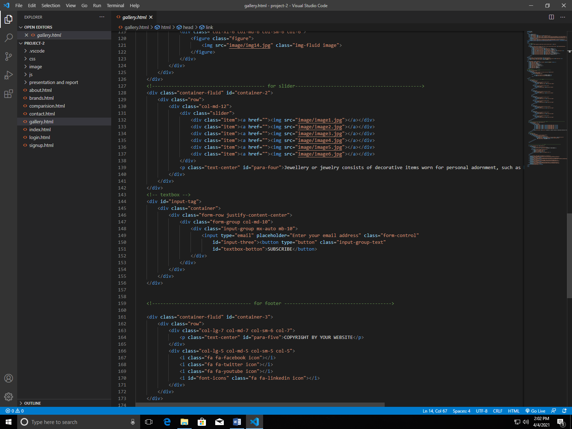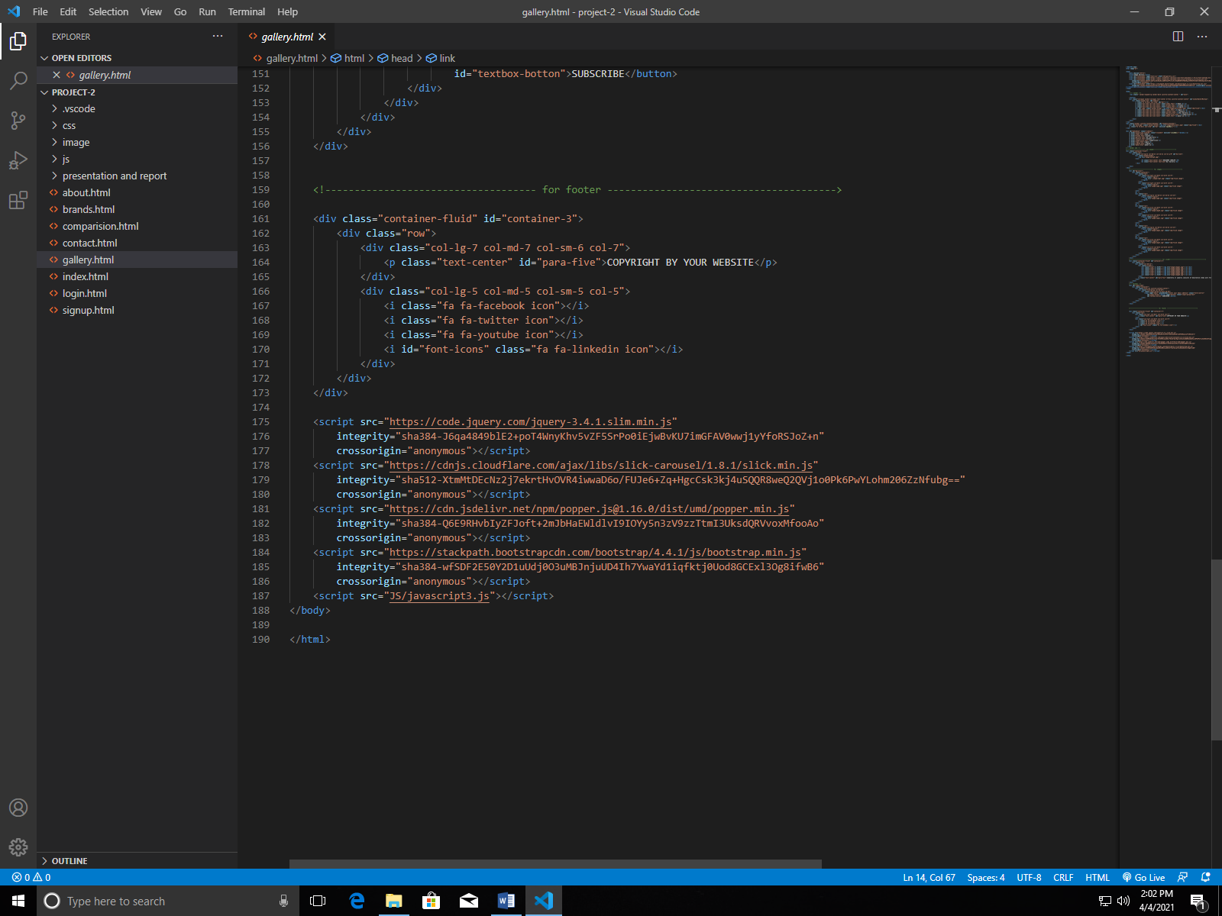

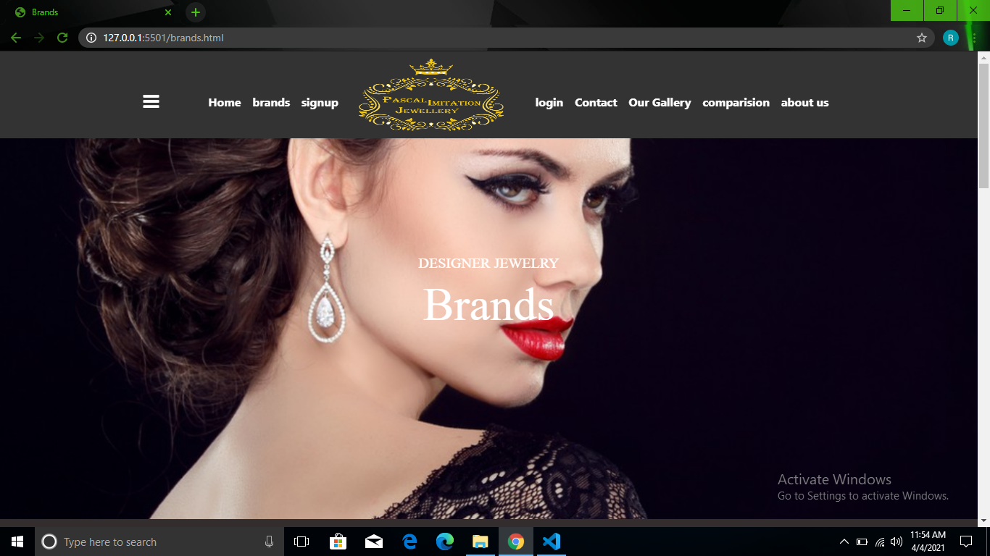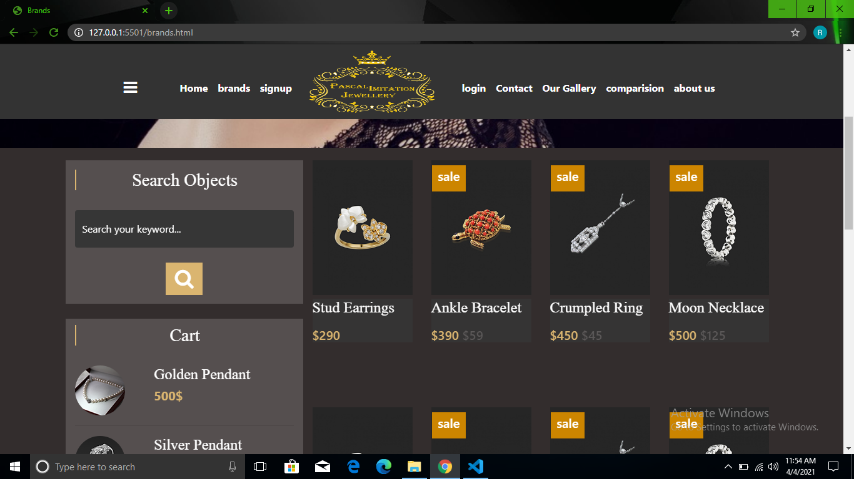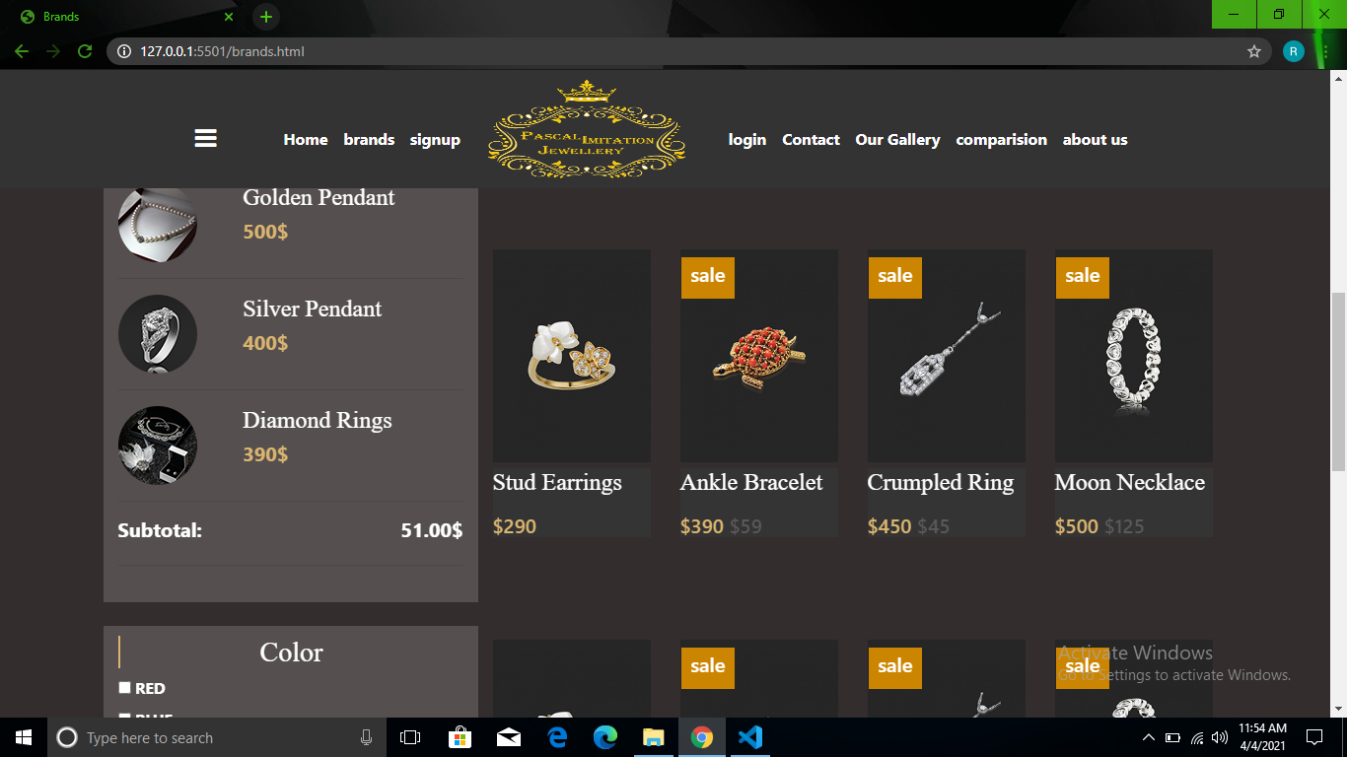

Screenshot OF BRANDS

Source Code OF Books Page

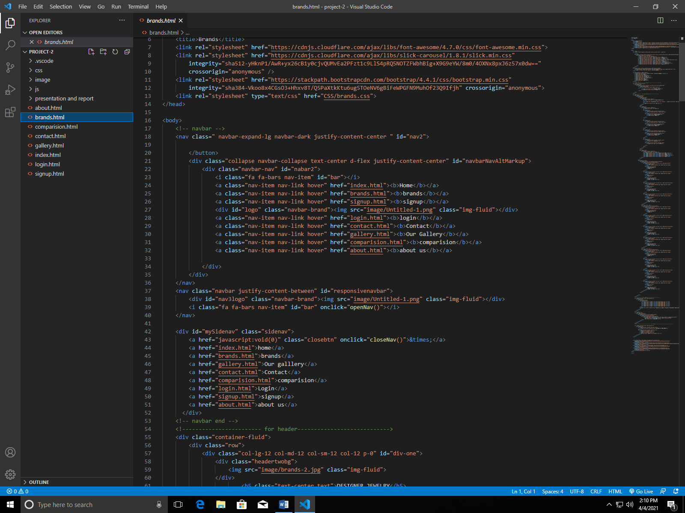

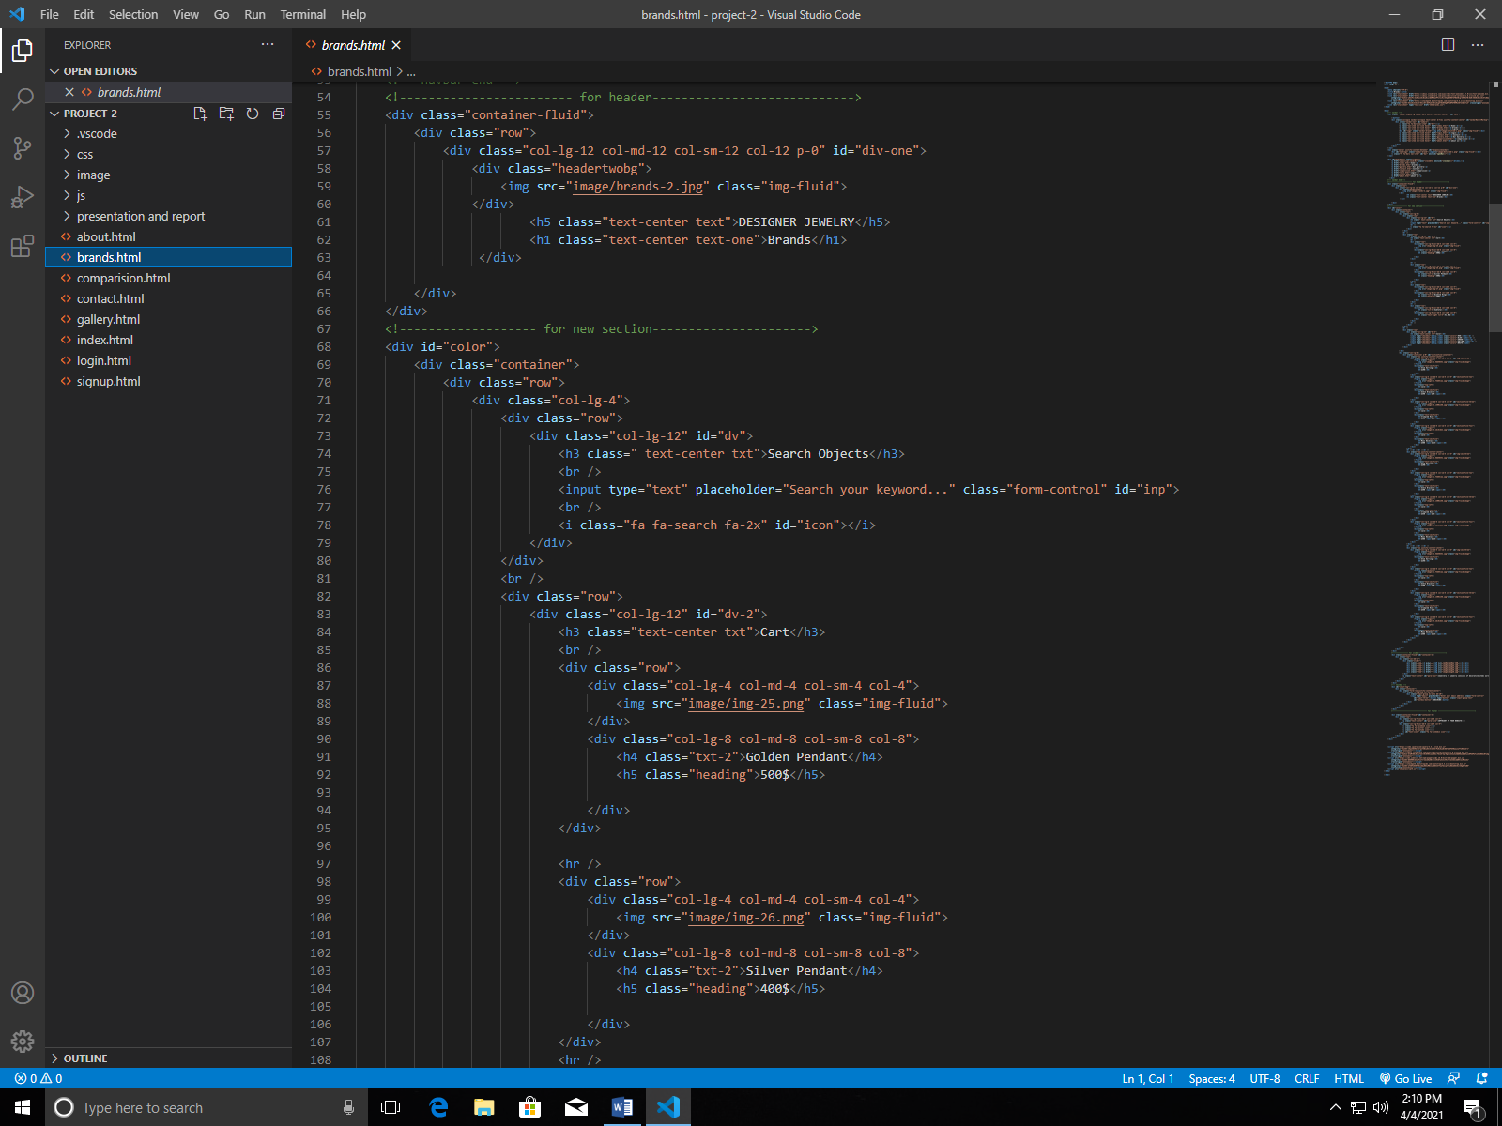

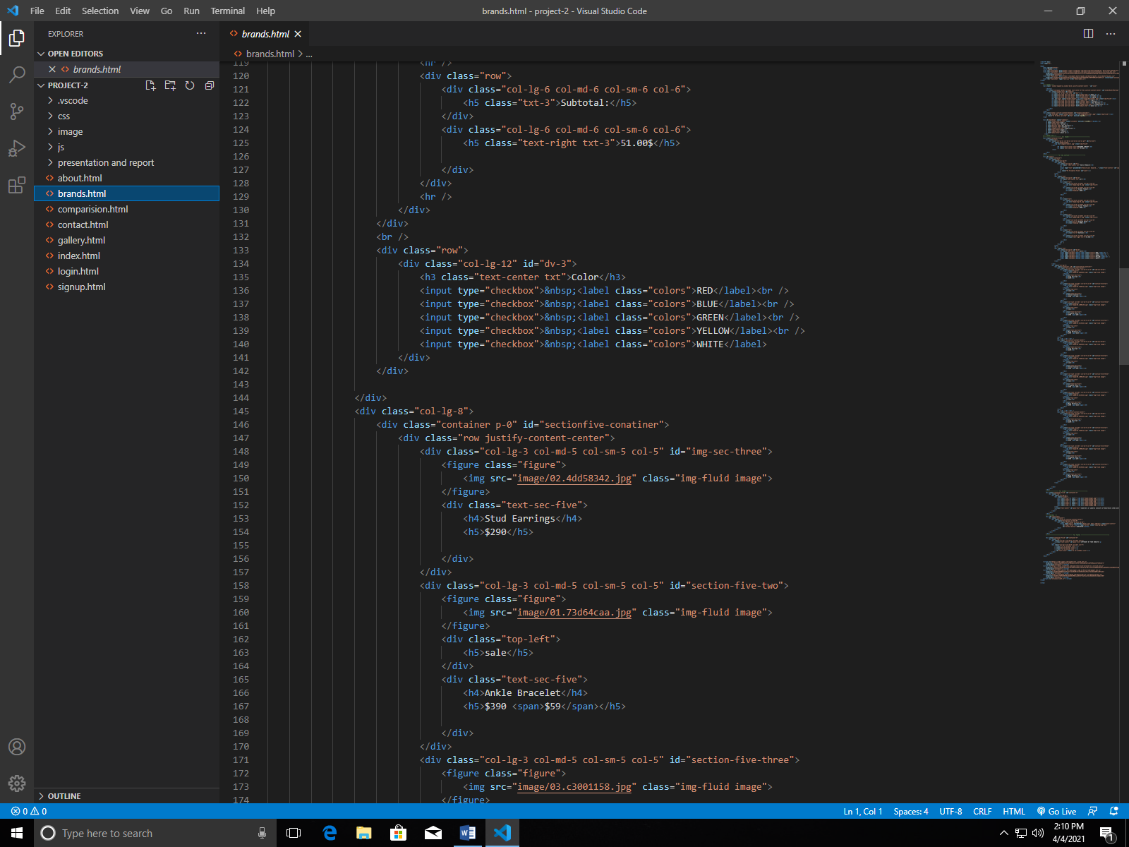

**Screenshot OF SIGN UP**

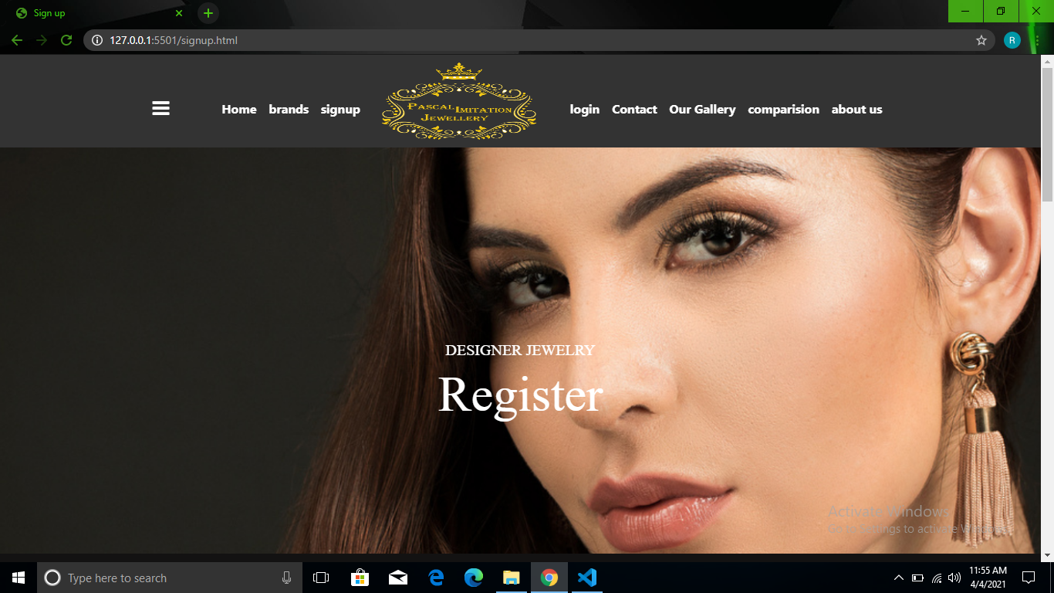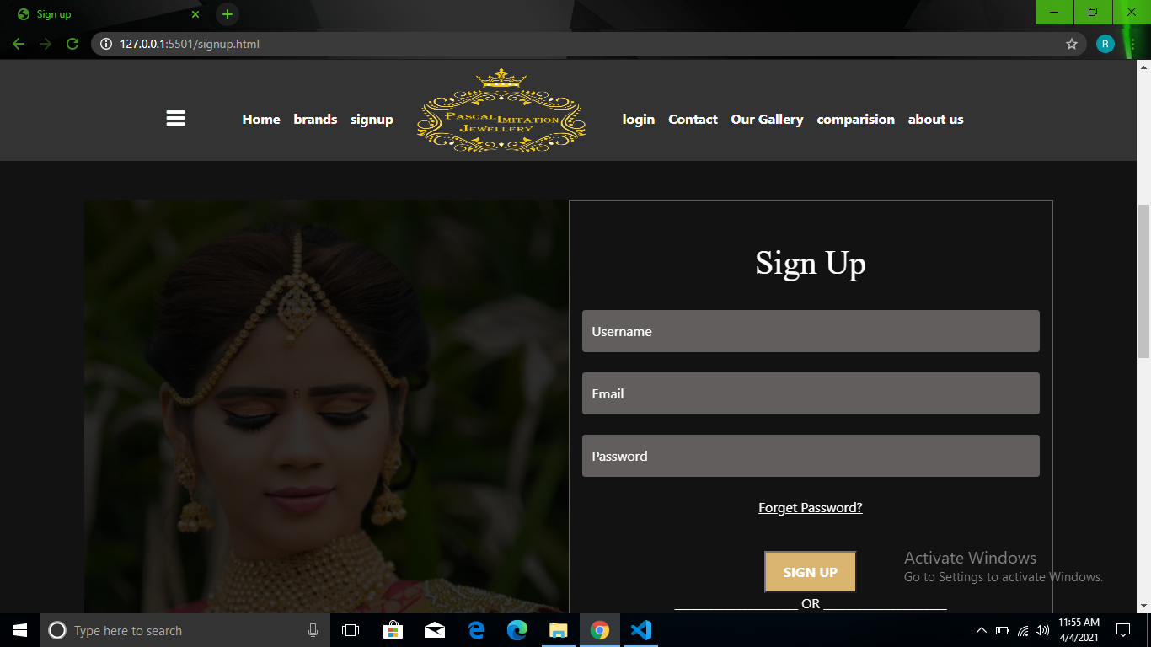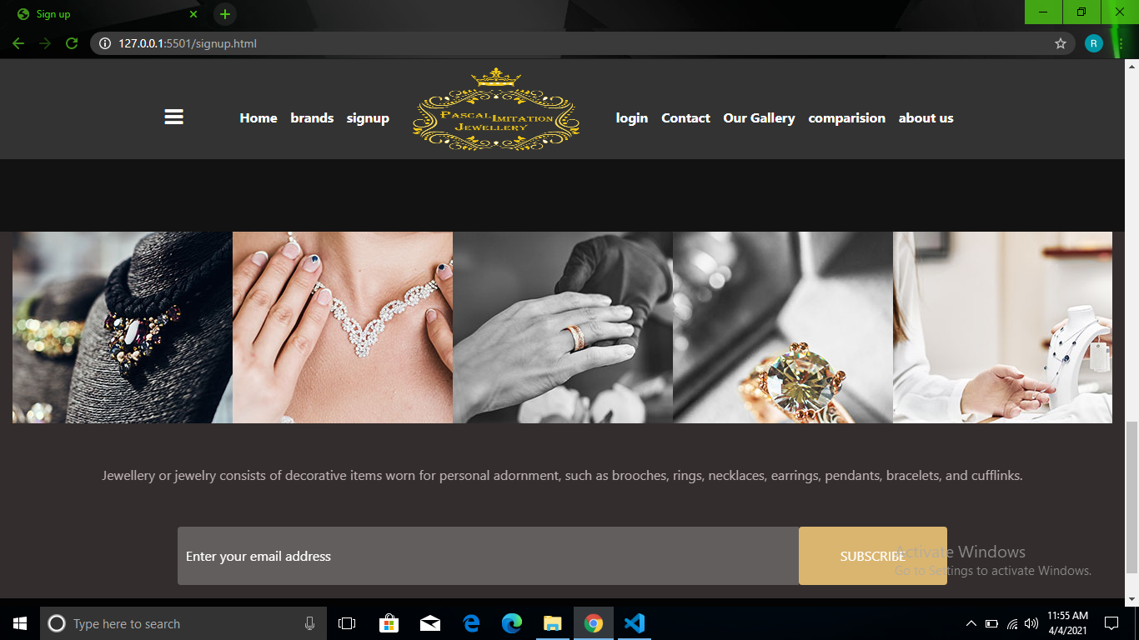

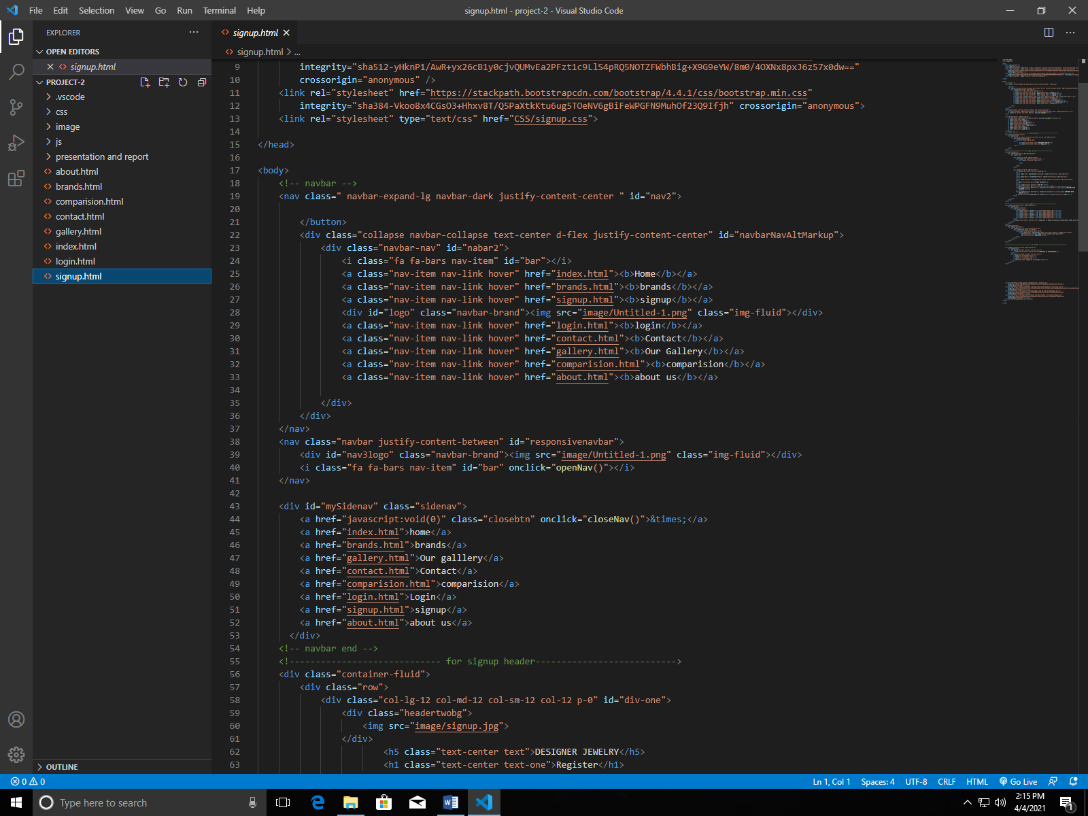

Source code Of Sign up

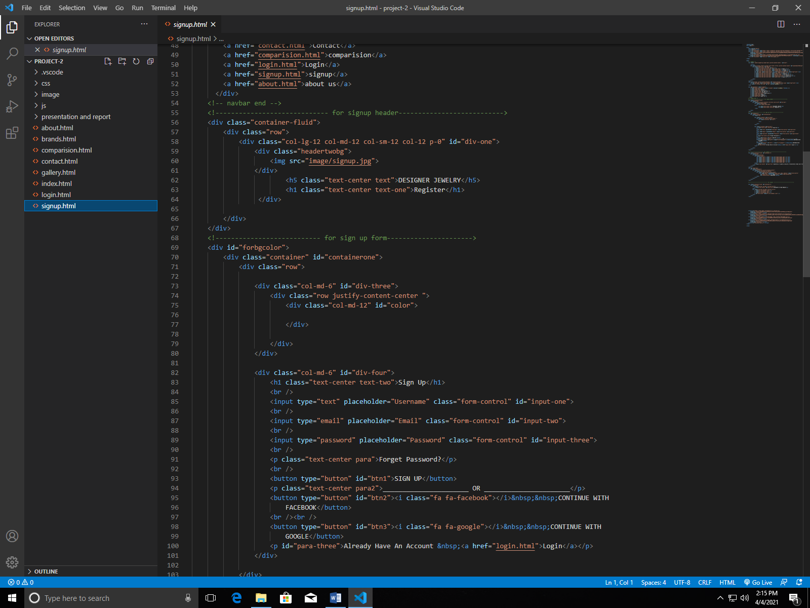

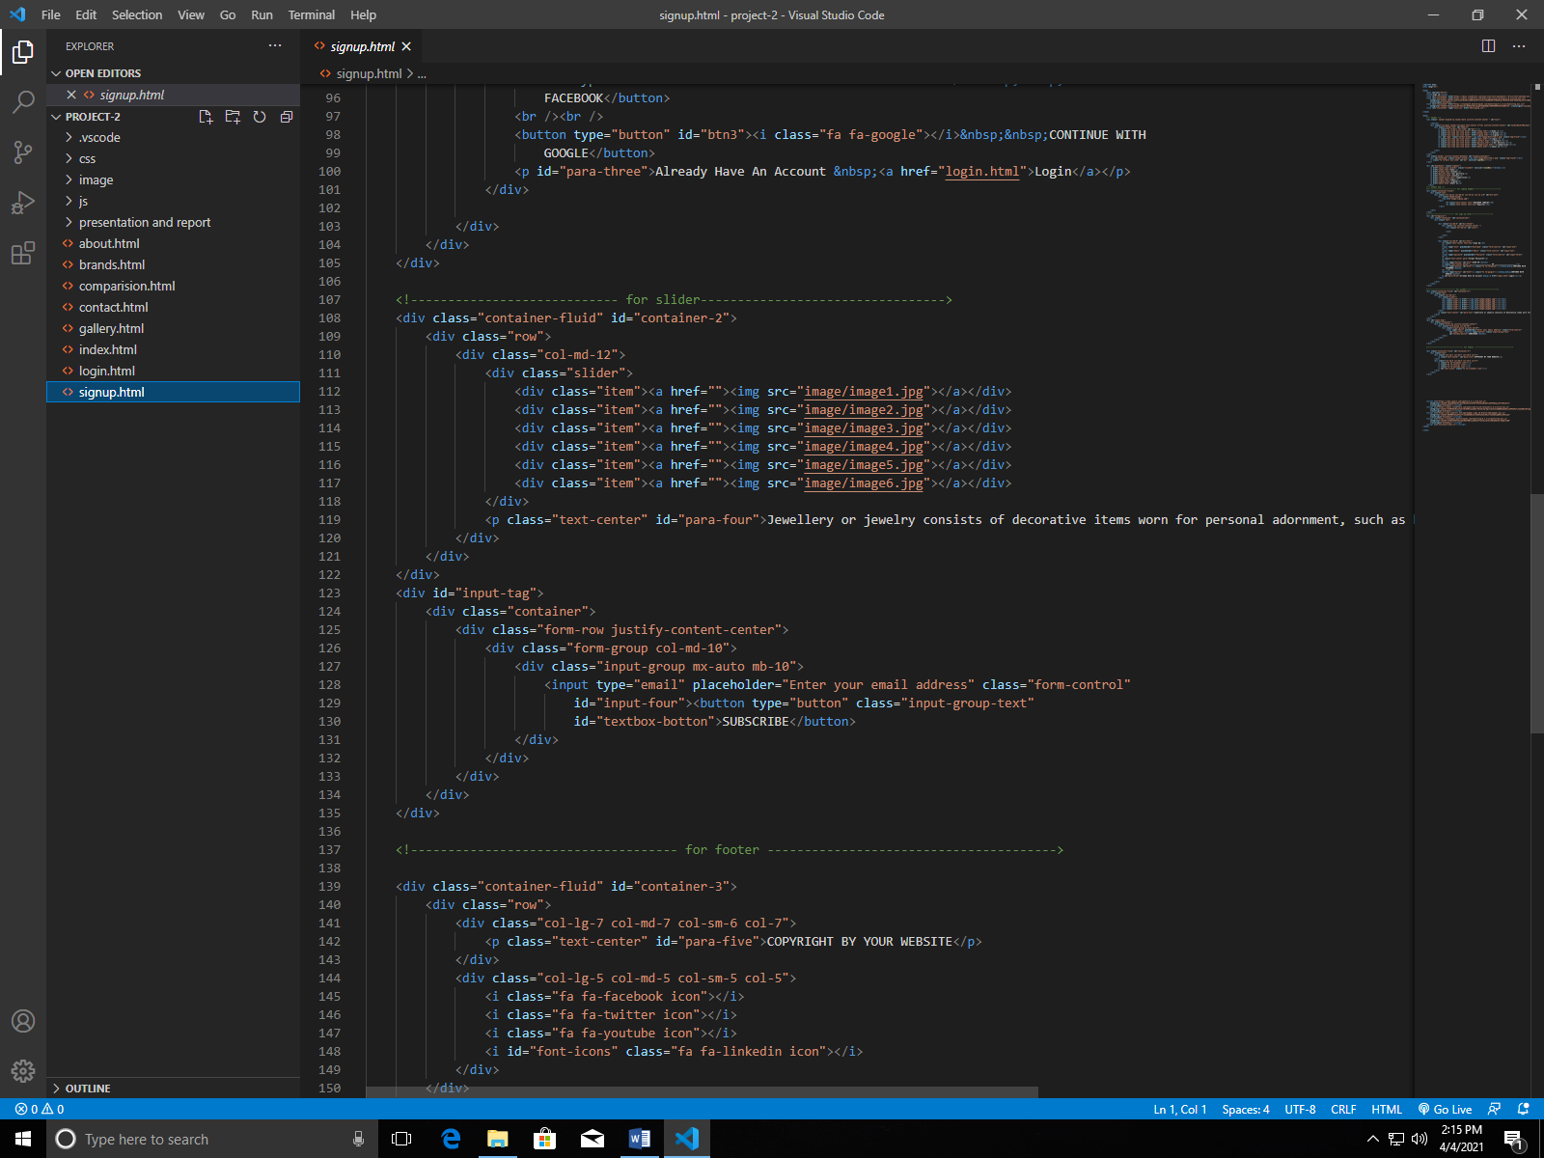

Screenshot Of login

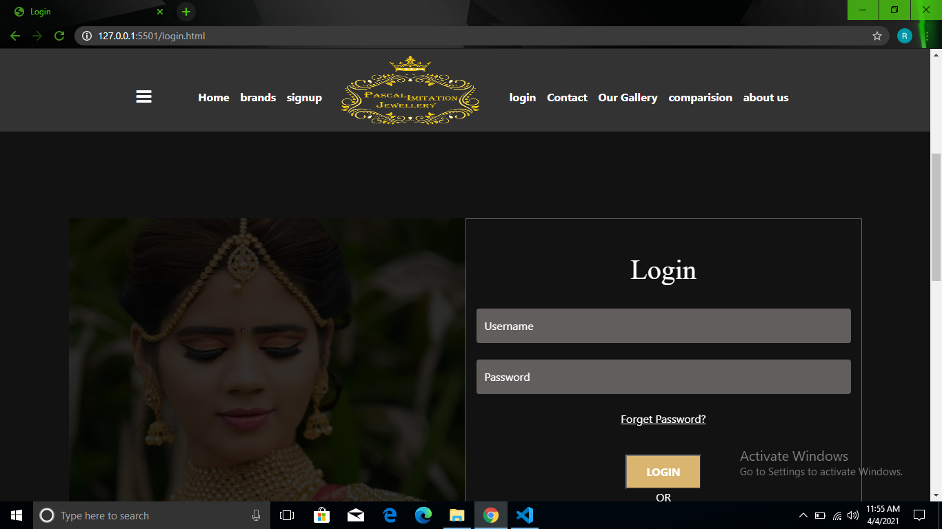

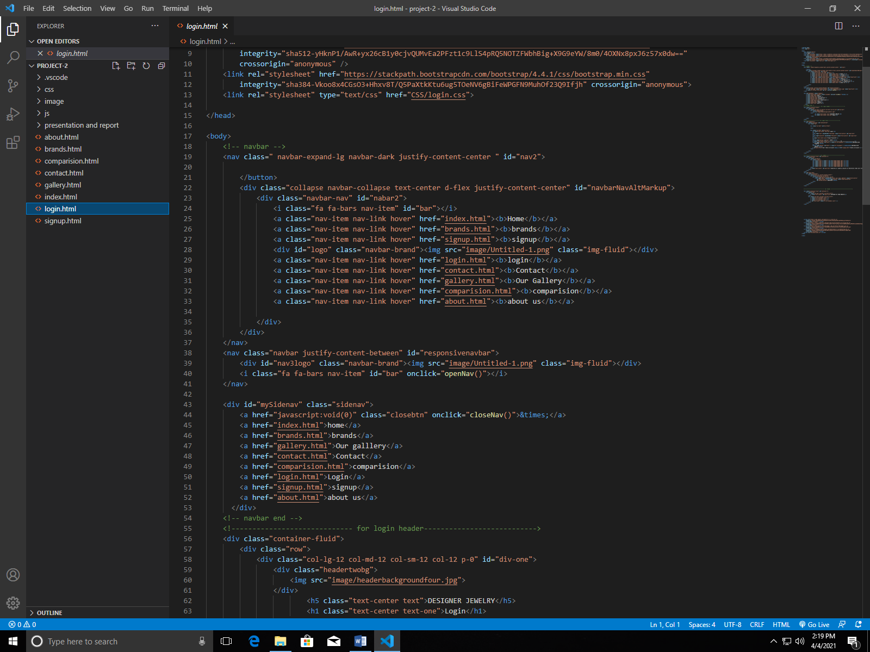

Source Code Of Signup Page

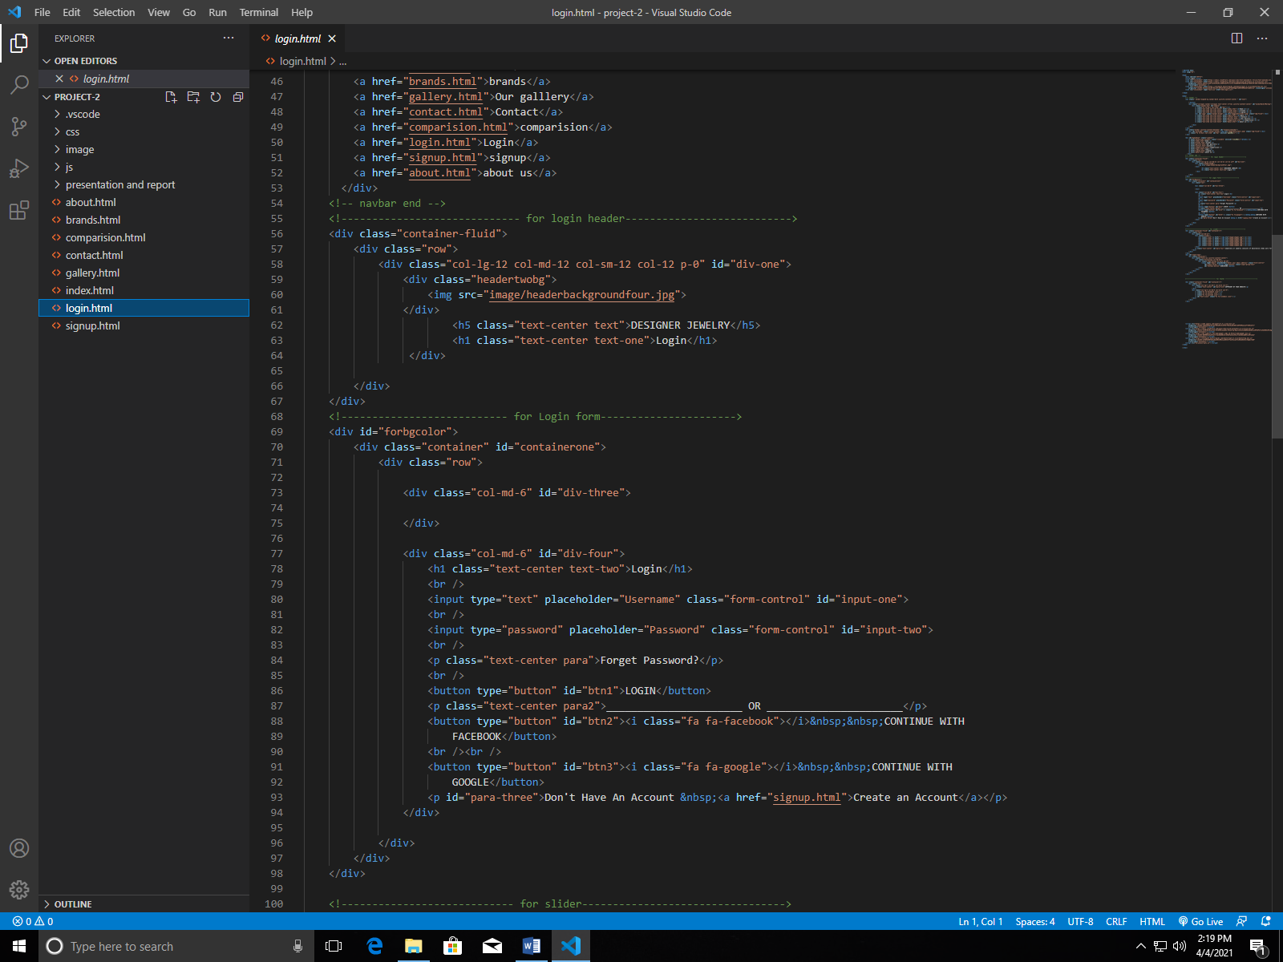

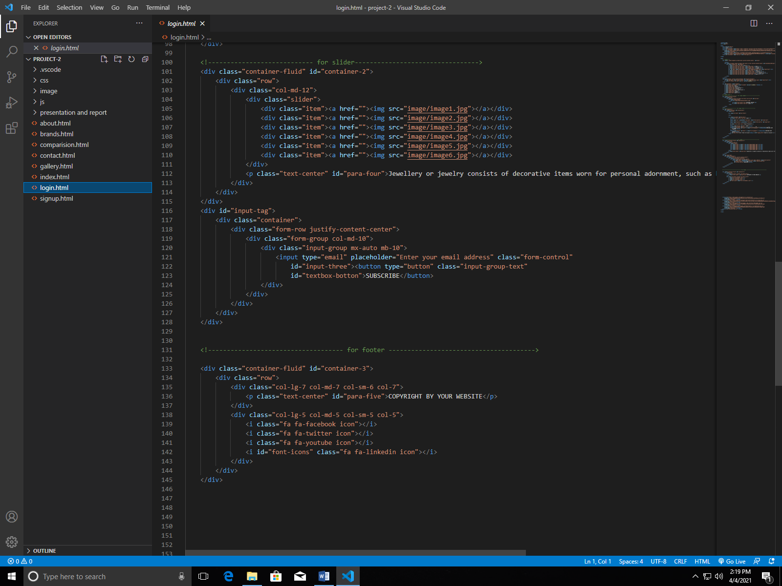

**DONE**

Hope You like It